System Compilation and Release Manual

Compile Working Environment
Jdk1.6.0_33、Maven 3.0.4、Tomcat 7.0

1.1、install jdk to configure the environment variables

1.2、install Maven to configure the environment variables
Link the path that is http://maven.apache.org/download.html to download Maven program. And then unzip the downloaded file to the local folder, for example D:\Program\apache-maven-3.0.4.
Set the environment variables as following mentioned. Add MAVEN_HOME to the name item and add its value that is the path of unzipped local folder as D:\Program\apache-maven-3.0.4 to the path item. Add ;%MAVEN_HOME%\bin to the end of the PATH variable to modify its value. Open cmd program and input mvn –v instruction to check whether the installation is successful.

1.3、install Tomcat

Compile
For example, checkout the source code to the directory that values D:\WorkSpace\MyEclipse\jcpa Maven Webapp.
1、Open cmd program and go to the directory that values D:\WorkSpace\MyEclipse\jcpa Maven Webapp.
2、Execute mvn clean instruction to delete the previous target directory. (If there is no target directory in the source codes, you don’t need to do this step.)
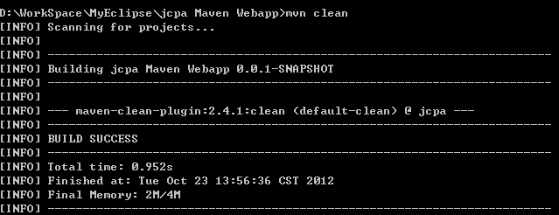
- Execute mvn package instruction to pack the program.
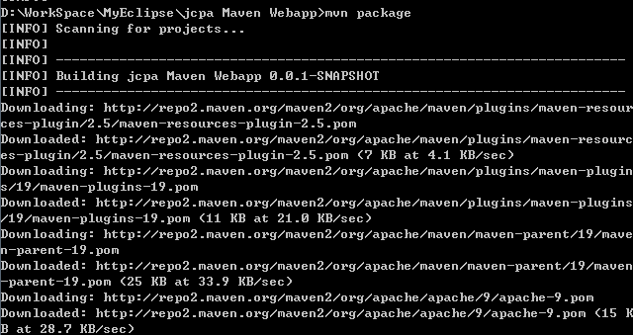
You can see a jar package is downloading by the maven program. If the downloading operation can’t be completed because of the speed or other reasons, please set maven repository or add the downloaded jar file to maven repository in accordance with the rules.( The default path is . M2 directory in the current user directory.)
- If you go to the target directory, you will see a war file which is packed through the above mentioned direction.
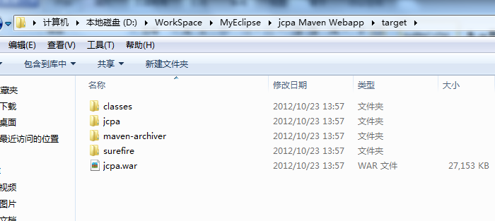

3、Release
Copy the compiled war package to the webapps directory of tomcat and start tomcat service, the website will release automatically. You can input the URL directly to access it.

Development Manual

File Structure of the System
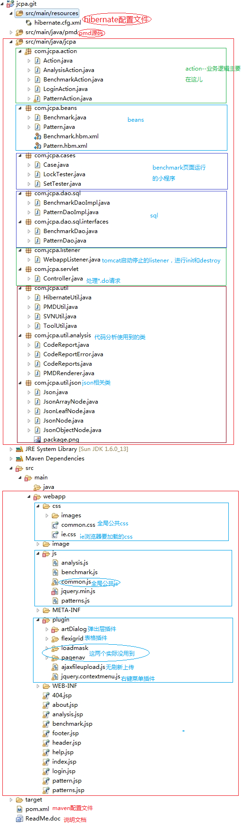

2、Main Menu
If you want to modify the menu, you need to open the file called header.jsp. Modify the classname of the div item which id equals menu to change the style and location of the main menu:
1、Level menu
<div id='menu' class="cssmenus hmenu">...</div>
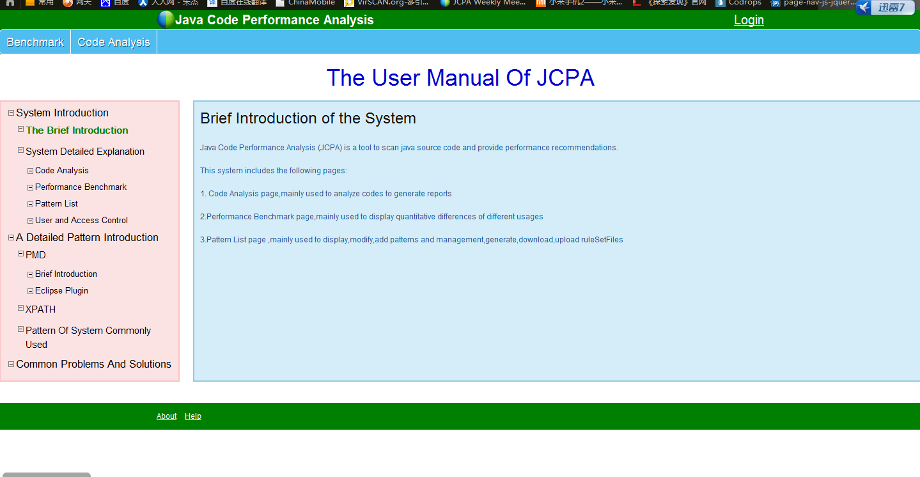
- Vertical to the right
<div id='menu' class="cssmenus vrmenu">...</div>
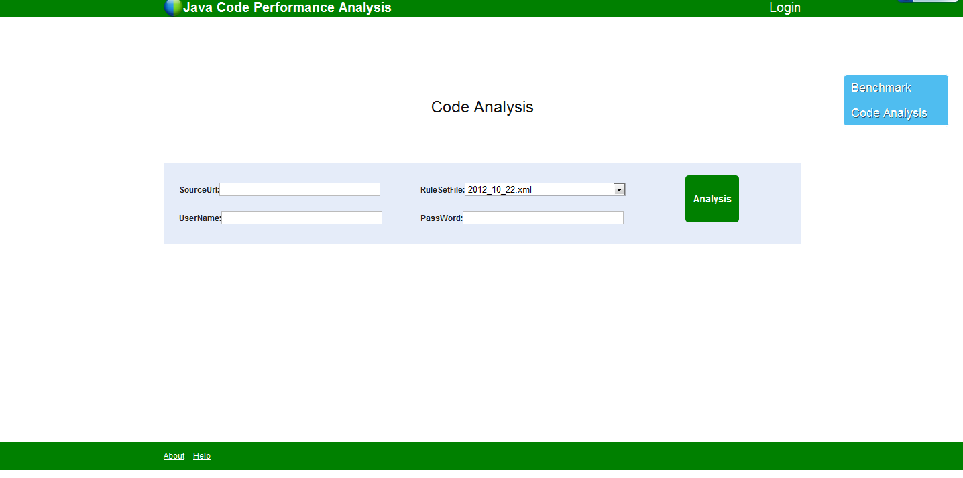
- Vertical to the left
<div id='menu' class="cssmenus vlmenu">...</div>
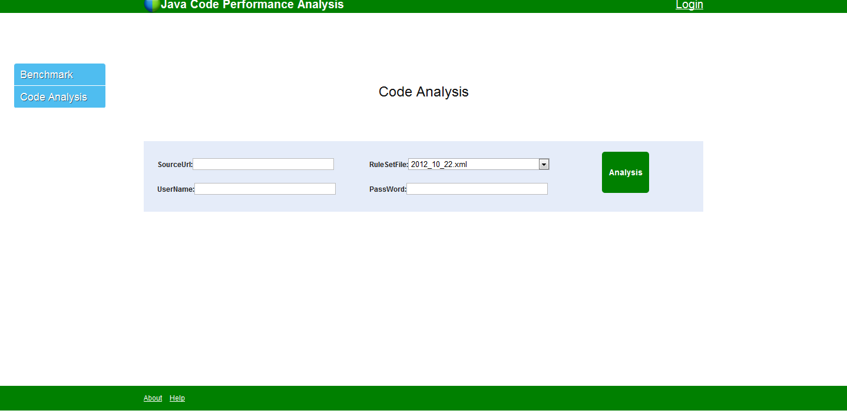

User Management
Modify the file called user.dat in WEB-INF folder to manage users. The format is one user per line that the user name and password separated by a space character. For example:
Admin password
Admin2 pwd2
Both the user name and the password of the default user is admin in the file called user.dat.

